Earl Judge, Daniel Williamson

CS126 Lab 3

Math Quiz

September 24, 2015

1)

For this lab we had to create a program that would take user input and determine how many questions to ask a user as well as the level of difficulty they wanted to work at. We did this using if, elif, and else statements. Along with this we had to make sure to calculate the final score they received using a system based off of 2/3 and 1/3. The beginner level had to have operands between 1 and 10, the intermediate level had to have operands between 1 and 25, and the advanced level had to have reasonable operands.

2)

To plan for this lab we developed questions that we thought would have been appropriate for the advanced level. We also had to set up a skeleton that would run a loop for the given input of beginner, intermediate, and advanced. We had to determine how to set up our if loops so that the total correct answers were calculated only at the very end to display how the user did. We drew out a rough outline of what we thought the code would look like. We also included the minimum requirements so we knew we could meet them all.

3)

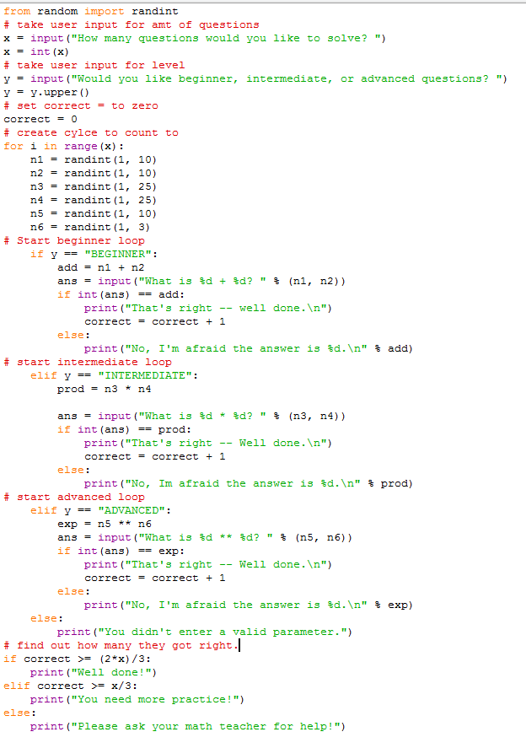

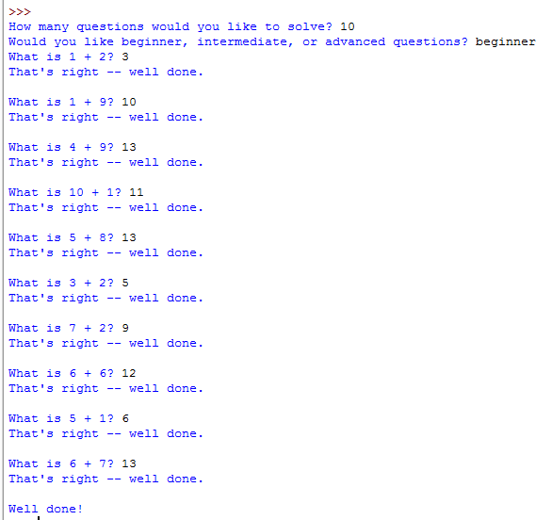

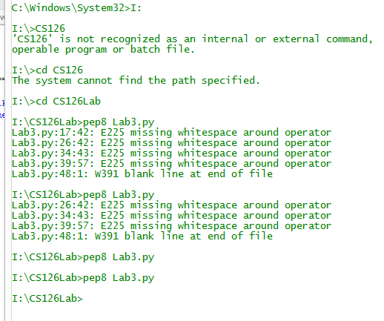

4)

This project was designed to allow the user to practice various level math problems with random integers. The process we used for this was a series of if, elif, and else statements. In order to make this project better we could have implemented more loops that offered different types of problems in order to better train the user. We could have also upped the range on all of the integers in order to offer more challenging and varied problems. Some of the key features were the upper command and the if, elif, and else statements. One last thing we could have done would have been to condense some of the code.